International workshop on the
Danger Model

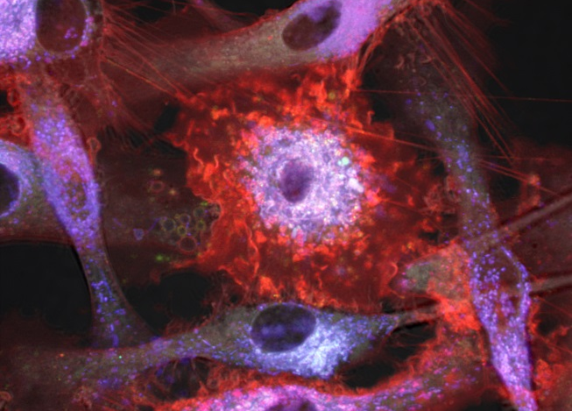
Photo by Ole J. B. Landsverk

Oslo, Norway, 22-23 June, 2017

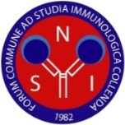

Meeting’s organizer: The Norwegian Society for Immunology (NSI)
http://norwegianimmunology.org; www.facebook.com/norwegianimmunology
Free entrance, everybody is welcome!

Limited number of seats: please sign up at
http://norwegianimmunology.org/meetings/nsi-events/

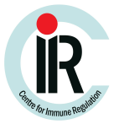
We are grateful to our sponsors:

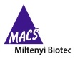
Official patrons of the Norwegian Society for Immunology:

1st Day – Thursday, June 22, 2017

Venue: Rikshospitalet, Store Auditorium, Sognsvannsveien 20, Oslo
Chair: Alexandre Corthay, Oslo University Hospital, NSI president

Session 1 Introduction to the Danger Model
09.00: Opening
Alexandre Corthay, Oslo University Hospital, NSI president
09.10: Danger and tolerance: transplants, pregnancy and tumors
Polly Matzinger, National Institutes of Health (NIH), Bethesda, USA
09.55: Discussion
10.25: Coffee break
10.55: Immunogenic cell death
Inger Øynebråten, Oslo University Hospital
11.25: Discussion
11.40: Organ transplants - the ultimate immune challenge
Einar Martin Aandahl, Oslo University Hospital
12.10: Discussion
12.25: Lunch break with wraps

Session 2 Other models for T cell activation and tolerance (part 1)
13.30: The Development-Context Model: putting danger in context
Colin C. Anderson, University of Alberta, Edmonton, Canada
14.15: Discussion
14.30: Lymphocyte cooperation initiates immune responses: a contemporary assessment
Peter Bretscher, University of Saskatchewan, Canada
15.15: Discussion
15.30: Coffee break

Session 3 Autoimmunity
16.00: Autoimmunity from a Danger point of view
Polly Matzinger, NIH, Bethesda, USA
16.45: Discussion
17.15: Triggers and drivers of autoimmunity
Ludvig Sollid, University of Oslo
18.00-18:30: Discussion
19.00-22:00: Pizza and beers (free discussion)

2nd Day – Friday, June 23, 2017

Venue: Store Auditorium, Rikshospitalet, Sognsvannsveien 20, Oslo
Chair: Alexandre Corthay, Oslo University Hospital, NSI president

Session 4 The Danger Model and Cancer
09.00: NK cell recognition of stressed self
Marit Inngjerdingen, Oslo University Hospital
09.30: Discussion
09.45: The danger model, self-nonself discrimination and cancer
Alexandre Corthay, Oslo University Hospital
10.30: Discussion
10.45: Coffee break

Session 5 Other models for T cell activation and tolerance (part 2)
11.15: On integrity in immunity
Zlatko Dembic, University of Oslo
12.00: Discussion
12.15: Lunch break with wraps
13.15: Idiotype-driven T-B collaboration and its pathogenic potential
Bjarne Bogen, University of Oslo
14.00: Discussion

Session 6 Danger signals
14.15: IL-33 - cytokine of dual function or novel alarmin?
Olav Sundnes, Oslo University Hospital
14.45: Discussion
15.00: Dual Blockade of Inflammation - targeting the complement system and
the TLR co-receptor CD14 in acute inflammatory disease.
Per Nilsson and Søren Pischke, University of Oslo
15.30: Discussion
15.45: Coffee break

Session 7 Immune Class Regulation
16.15: Quantitation and Immune Class Regulation: The Threshold Hypothesis
Peter Bretscher, University of Saskatchewan, Canada
17.00: Discussion
17.15: Class control: the other side of tolerance
Polly Matzinger, NIH, Bethesda, USA
18.00-19:00: Discussion

19.30: Dinner

